# DUAL AXIS SOLAR TRACKER

*A Project Work*

*Submitted in partial ful-fillment of Requirements for the Award of*

### DIPLOMA

IN

**ELECTRONICS & COMMUNICATION ENGINEERING**

BY

**P. KARTHIK (20352-EC-043) R. SN. NANDA (20352-EC-051) G. RISHITHA (20352-EC-017) K. RAVI KIRAN (20352-EC-026)**

**T. SANATH KUMAR (20352-EC-059)**

Under the Esteemed guidance of **MS. A. SAI SRUTHI M.TECH** LECTURER

**DEPARTMENT OF ELECTRONICS & COMMUNICATION ENGINEERING DHANEKULA INSTITUTE OF ENGINEERING & TECHNOLOGY GANGURU, VIJAYAWADA-521 139**

**Affiliated to JNTUK, Kakinada & Approved By AICTE, New Delhi Certified by ISO 9001-2015, Accredited by NAAC & NBA**

**2020-2022**

**DHANEKULA INSTITUTE OF ENGINEERING & TECHNOLOGY**

**GANGURU, VIJAYAWADA-521 139**

**Affiliated to JNTUK, Kakinada & Approved By AICTE, New Delhi Certified by ISO 9001-2015, Accredited by NAAC & NBA**

**DEPARTMENT OF ELECTRONICS & COMMUNICATION ENGINEERING**



**CERTIFICATE**

This is to certify that the project work entitled "**DUAL AXIS SOLAR TRACKER**" is a bonafide work of **G. RISHITHA (20352-EC-017), K. RAVIKIRAN (20352-EC- 026)**, **P. KARTHIK (20352-EC-43), R. SN.NANDA (20352-EC-051), T.SANATH**

**KUMAR (20352-EC-059)** Of III -Year, V semester D.E.C.E is going to be submitted in partial fulfilment of the requirement for the award of Diploma in Electronics& communication Engineering by the Andhra Pradesh State Board of Technical Education & Training during the academic session 2020-2022.

**Project Guide Head of the Department**

MS. A. SAI SRUTHIM.TECH MR. V. AYYAPPAM.TECH

**EXTERNAL EXAMINER**

## ACKNOWLEDGEMENT

It is great pleasure for us to express our sincere thanks to our honourable Principal Sri .Dr. K. Ravi who had inspired lot through his speeches. He is the only personality who had given the meaning to the technology and told us how to survive in this competitive world.

We express our deep sense of heartful thanks to **Sri. M. Praveen** in charge of Diploma courses for his cheerful motivation and encouragement at the stage of his endeavor. We are indebted to him.

We express our deep sense of heartful thanks to **Mr. V. AYYAPPA** Head of Electronics& Communication Engineering Department for her cheerful motivation and encouragement at the stage of her endeavor. We are indebted to him.

We record with pleasure our deep sense of gratitude to our beloved project guide. **Ms. A. SAI SRUTHI** Lecturer of Electrical & Electronics Engineering Department, for the stimulating guidance and profuse assistance. We have from this throughout the course of the project work. We should always cherish our association with her for her encouragement, approachability & freedom of through and action. We have enjoyed during this project work.

We are very thankful to the entire faculty of Electronics& Communication Engineering Department, for the co-operation in completing this project.

**PROJECT ASSOCIATES**

**GOGULAMUDI RISHITHA (20352-EC-017)**

**KODALI RAVI KIRAN (20352-EC-026)**

**PASUPULETIKARTHIK (20352-EC-043)**

**RAMISETTY SANKAR NARAYAN NANDA (20352-EC-051)**

**TEKKEM SANATHKUMAR4 (20352-EC-059)**

**THIS PROJECT WORK IS APPROVED BY THE FOLLOWING BOARD OF EXAMINERS**

INTERNAL EXAMAINER EXTERNAL EXAMAINER

**PROJECT ASSOCIATES**

**G. RISHITHA (20352-EC-017)**

**K. RAVI KIRAN (20352-EC-026) P. KARTHIK (20352-EC-043)**

**R. SN. NANDA (20352-EC-051)**

**T. SANATH KUMAR (20352-EC-059)**

**DECLERATION**

#### We the members of the project **“DUAL AXIS SOLAR TRACKER”** hereby declare that the matter embodied in this project is the genuine work carried out by us and has not been submitted either to this college or to any other institute for the fulfilment of the requirement of any other course of study.

**PROJECT ASSOCIATES**

**G. RISHITHA (20352-EC-017)**

**K. RAVI KIRAN (20352-EC-026) P. KARTHIK (20352-EC-043)**

**R. SN. NANDA (20352-EC-051)**

**T. SANATH KUMAR (20352-EC-059)**

## CONTENTS

**VISION, MISSION OF INSTITUTE & DEPARTMENTS, PEO’s** I

STATEMENT OF PO’s & PSO’s II

LIST OF FIGURES III-IV

ABSTRACT V

CHAPTER NO TITLE PAGE NO

1. INTRODUCTION 1
   1. Introduction 1-3
   2. Problem statement 4
2. LITERATURE SURVEY 5
   1. Literature Survey 5
   2. Classification of Solar tracking system 5
      1. Degree of freedom 6
3. HARDWARE COMPONENTS 7
   1. Hardware components 7
   2. About components 8
      1. Basic components 8-12
      2. Main components 13-21
4. DUAL AXIS SOLAR TRACKING SYSTEM 22
   1. Block diagram 22-23
   2. Flow chart 24
   3. Circuit diagram 25-26
5. PERFORMANCE ANAYLSIS & RESULTS 27-28
6. RESULT 29-30
7. CONCLUSION 31
8. FUTURE SCOPE 32
9. REFERENCES 33

**DHANEKULA INSTITUTE OF ENGINEERING & TECHNOLOGY DIPLOMA COURSES**

**DEPARTMENT OF ELECTRONICS & COMMUNICATION ENGINEERING VISION**

Develop Electronics and Communication Engineering professionals competent to face the global challenges in a progressive environment conducive to learn technical knowledge, skills blended with ethics and values, to serve the society and to better it for a happy and comfortable living.

**MISSION**

**M1:** To provide a competitive learning environment, through a need base curriculum designed in collaboration with industry, conducive for high quality education emphasising on transfer of knowledge and skill development essential for the profession and the society as well.

**M2:** To nurture higher order leadership qualities and ethics and values in students to enable them to be leaders in their chosen professions while maintaining the highest level of ethics.

**M3:** To encourage the spirit of inquisition to promote innovation and entrepreneurship and strengthened with life skills, to sustain the stress.

**M4:** To foster effective interactions and networking with all the stake holders so as to work Towards the growth and sustainability of the society and environment.

**Programme Educational Objectives (PEOs)**

Diploma in Electronics and Communication Engineering programme is steadfast to transform students in to competent professionals with qualities of good human values and responsible citizens. On completion of the Diploma programme, the students should have acquired the following characteristics

**PEO1:** To apply technical knowledge and management principles in analysing and planning. Problems in the field of electronics and Communication Engineering while ensuring maximization of economic benefits to society and minimization of damage to ecology and environment.

**PEO2:** To be life-long learners with sprit of enquiry and zeal to acquire new knowledge and skills so as to remain contemporary and possess required professional skills.

**PEO3:** To enhance entrepreneurial, communication and other soft skills, which will enable them to work globally as leaders, team members and contribute to nation building for the betterment of the society.

**PEO4:** To make them strongly committed to the highest levels of professional ethics and focus on ensuring quality, adherence to public policy and law, safety, reliability and environmental sustainability in all their professional activities

**Program Outcomes (POs)**

1. **BASICAND DISCIPLINE SPECIFIC KNOWLEDGE:** Apply knowledge of basic mathematics, Science and engineering fundamentals and engineering specialization to solve the engineering problems.
2. **PROBLEM ANALYSIS:** Identify and analyse well-defined engineering problems using codified Standard methods.
3. **DESIGN/DEVELOPMENT OF SOLUTONS:** Design solutions for well-defined technical problems and assist with the design of systems components or processes to meet specified needs.
4. **ENGINEERING TOOLS, EXPERIMENTATION AND TESTING:** Apply modern engineering tools and appropriate technique to conduct standard tests and measurements.
5. **ENGINEERING PRACTICES FOR SOCIETY, SUSTAINNABILITY AND ENVIRONMENT:** Apply Appropriate technology in context of society, sustainability, environment and ethical Practices.
6. **PROJECT MANAGEMENT:** Use engineering management principles individually, as a team member or a leader to manage projects and effectively communicate about well-defined engineering activity.
7. **LIFE-LONG LEARNING:** Ability to analyse individual needs and engaging updating in the Context of technological changes.

**Programme Specific Outcomes (PSOs)**

1. An ability to understand the concepts of basic Electronics &amp; Communication Engineering and to apply them to various areas like signal processing. VLSI, embedded systems. Communication systems, Digital & amp; Analog Devices etc.
2. An ability to solve complex Electronics and Communication Engineering problems using latest hardware and software tools, along with analytical skills to arrive cost effective and appropriate solutions.
3. Wisdom and social awareness along with ethical responsibility to have a successful career in the field of Electronics and to sustain passion and zeal for real world applications in the field of Electronics using optical resources as per Entrepreneur.

## LIST OF FIGURES

**FIGURE N.O FIGURE NAME PAGE N.O**

1.1 Layers of solar PV module 2

* 1. Single axis solar tracker 6
  2. Dual axis solar tracker 6
  3. Cardboard 8
  4. Solderless breadboard 8
  5. Resistor 9
  6. Capacitor 9
  7. Variable resistor 10
  8. Light Emitting Diode (LED) 10
  9. DC fan 11
  10. ON/OFF Switch 11
  11. Battery holder 12
  12. 555 Timer IC with pin configuration 13
  13. Internal block diagram of 555 Timer IC 14
  14. LM358 IC pinout 15

3.13 L293D IC 16

3.14 L293D pin configuration 16

3.15 1N4148 Diode 17

* 1. MG996R servo motor with dimensions 17
  2. LDR Sensor 18
  3. LM25887 boost convertor 19
  4. Battery cells 19
  5. TP4056 mini battery charging module 20
  6. Layers of a solar panel 21
  7. Functional block diagram 22
  8. Algorithm for tracking 24
  9. Circuit diagram of dual axis solar tracking system 25
  10. Current and voltage values of static and tracking 27

panel at different times in a day

* 1. Day based obtained output 28
  2. Comparison with static and single axis 28
  3. Model of Dual axis solar tracking system 29
  4. Dual axis solar tracker with DC fan and LED as output 29
  5. Dual axis solar tracker with LED ON & OFF 30

## ABSTRACT

The main objective of this project is to design an automated dual axis solar tracker system. Solar energy is one of the most effective resources of the renewable energy which could play a significant role to solve the energy crises. The proposed system uses tracker to actively track the solar radiation and accordingly adjust the panel to maximize the power output.

Our project will include the design and construction of the dual axis solar tracking panel that captures maximum solar energy than a stationary solar panel captures. It also includes rechargeable batteries to store the energy that is absorbed by the solar panel, thereby making this project to work in more efficient way.

# CHAPTER 1

## INTRODUCTION

### INTRODUCTION

When it comes to the development of any nation, energy is the main driving factor. There is an enormous quantity of energy that gets extracted, distributed, converted and consumed every single day in the global society. The world population is increasing day by day and the demand for energy is increasing accordingly. Oil and coal are the main source of energy nowadays but there is a fact that the fossil fuels are limited and hand strong pollution. Even the price of petroleum has been increasing year by year and the previsions on the medium term there are not quite encouraging. Utilization of this resources increases the emission of carbon monoxide (CO), hydrogen chloride (HCL), Nitrogen Oxides, and Sulphur Oxides which are responsible for the global warming and greenhouse effect. This results the devastating effect in the environment. With the view point of minimizing above mentioned problems, many researched have been carried since late 19th century by researchers and engineers. Renewable energy sources as an alternative to fossil fuel were the major found out. They are derived from natural processes that are replenished constantly. Renewable energies are inexhaustible and clean. The energy comes from natural resources such as sun, wind, tides, waves, and geothermal heat. Solar energy is quite simply the energy produced directly by the sun. The history of solar energy is as old as humankind. In general, solar energy is radiant light and heat from the sun harnessed using a range of technologies such as photovoltaic and concentrator. In the last two centuries, we started using Sun's energy directly to make electricity.

In 1839, Alexandre Edmond Becquerel discovered that certain materials produced small amounts of electric current when exposed to light. In 1876, When William Grylls Adams and his student, Richard Evans Day, discovered that an electrical current could be started in selenium solely by exposing it to light, they felt confident that they had discovered something completely new. Werner von Siemens, a contemporary whose reputation in the field of electricity ranked him alongside Thomas Edison, called the

discovery “scientifically of the most far-reaching importance.” This pioneering work portended quantum mechanics long before most chemists and physicist had accepted the reality of atoms. Although selenium solar cells failed to convert enough sunlight to 2 power electrical equipment, they proved that a solid material could change light into electricity without heat or any moving parts. Later in 1905 Albert Einstein published the first theoretical work describing the photovoltaic effect titled “Concerning a Heuristic Point of View Toward the Emission and Transformation of Light.” In the paper, he showed that light possesses an attribute that earlier scientists had not recognized. Light, Einstein discovered, contains packets of energy, which he called light quanta. Einstein’s bold and novel description of light, combined with the [1898] discovery of the electron, gave scientists in the second decade of the twentieth century a better understanding of photo electricity. They saw that the more powerful photons carry enough energy to knock poorly linked electrons from their atomic orbits in materials like selenium. When wires are attached, the liberated electrons flow through them as electricity. By the 1920s, scientists referred to the phenomenon as the “photovoltaic effect.” In 1953, Bell Laboratories (now AT&T labs) scientists Gerald Pearson, Daryl Chapin and Calvin Fuller developed the first silicon solar cell capable of generating a measurable electric current. The New York Times reported the discovery as “the beginning of a new era, leading eventually to the realization of harnessing the almost limitless energy of the sun for the uses of civilization. After years of experiments to

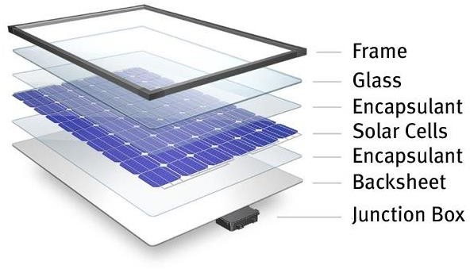

**Figure 1.1: Layers of solar PV module**

improve the efficiency and commercialization of solar power, solar energy gained support when the government used it to power space exploration equipment in 1958. The first solar-powered satellite, Vanguard 1, has travel more than 197,000 revolutions around Earth in the 50 years. Consequently, in 1982 and 1985 first solar parks and retractable RV solar panels are created respectively. In 1994, the National Renewable Energy Laboratory developed a new solar cell from gallium indium phosphide and gallium arsenide that

exceeded 30% conversion efficiency. By the end of the century, the laboratory created thin-film solar cells that converted 32% of the sunlight it collected into usable energy. Due to dedicated research worldwide, the efficiency of photovoltaics has continued to increase while production costs have also dropped substantially over the years. A solar cell (also called a photovoltaic cell) is an electrical device that converts the energy of light directly into electricity by the photovoltaic effect. A solar panel is a set of solar photovoltaic modules electrically connected and mounted on a supporting structure. The layer of solar module is shown in Figure 1.1

The majority of modules use wafer based crystalline silicon cells or thin-film cells based on cadmium telluride or silicon. The structural member of a module can either be the top layer or the back layer. Electrical connections are made in series to achieve a desired output voltage and in parallel to provide a desired current capability. Several types of solar cells are available. Monocrystalline Solar Cells, Polycrystalline Solar Cells, Amorphous Silicon (a-Si) Solar Cells, Cadmium Telluride (CdTe) Solar Cells. Their efficiency is 24.5% on the higher side. Three ways of increasing the efficiency of the solar panels are through increase of cell efficiency, maximizing the power output and the use of a tracking system. Maximum power point tracking (MPPT) is the process of maximizing the power output from the solar panel by keeping its operation on the knee point of P-V characteristics. MPPT technology will only offer maximum power which can be received from stationary arrays of solar panels at any given time. Automatic solar tracker increases the efficiency of the solar panel by keeping the solar panel aligned with the rotating sun. Solar tracking is a mechanized system to track the sun’s position that increases power output of solar panel 30% to 60% than the stationary system. S. Shanmugam et al. had given the tracking of the sun for solar paraboloid dish concentrators in 2005. Rong-Jong Wai et al. had given grid connected photovoltaic (PV) generation system with an adaptive step-perturbation (ASP) method and an active sun tracking scheme in 2006. Cemil Sungur had given the electromechanical control system of a photovoltaic (PV) panel tracking the sun on the axis it moved along according to its azimuth angle in 2007. The elevation angle of the sun be in the same place almost invariant in a month and varies little (latitude ± 10°) in a year. Therefore, a single axis position control scheme may be enough for the collection of solar energy 4 in some applications (Konar and Mandal, 1991. Yeong-Chau, et al., 2001. Wilamowski and Xiangli, 2002).

### Problem statement

The main goal is to keep solar PV panel perpendicular to the sun throughout the day in order to increase the energy generation. Dual axis solar tracking system can be an effective way to increase the efficiency of solar cells. The devastating problem on both biotic and abiotic components of our home (i.e., pollution) can be reduced by using solar energy as the major source for power generation. The natural gift like fossil fuels, woods, etc. which are limited in amount can be saved from crisis and extinction. For people, due to its more efficiency and less harmful impacts dual axis solar tracking system might be good decision for the intermediate future. So, this project can practically demonstrate effect of this variation to people.

# CHAPTER 2

## LITERATURE SURVEY

### LITERATURE SURVEY

C. Finster's mechanical mechanism, created in 1962, was the first sun tracker. Despite the Finster solar tracker's negligible energy gains, years of testing and development have improved the PV system's conversion output, necessitating the use of various tracking technologies and applications (e.g., concentrator and non-concentrator). In brief, better solar cells have been created, and solar tracking systems have become more popular than traditional fixed PV systems. The solar receiver (PV module) in a fixed photovoltaic system is fixed and facing true north. With mechanical or electro-mechanical systems, the collector's orientation in relation to azimuthal directions (east-west) and its height, however, alter continuously. This depends on the tracker’s geometrical capacity.

### CLASSIFICATION OF SOLAR TRACKING SYSTEMS

**Auxiliary Bifacial Solar Cell Tracker -** This form of tracker uses an auxiliary PV cell, which is coupled to a permanent magnet DC motor, to sense the position of the sun and also to supply the tracking energy. Both of these are attached to the tracker's drive axle.

**Chronological tracker** - Employs mathematical formulas and algorithms to determine the relative movement of the sun over a certain period of time (day and month) based on geographic and astronomical data. The system will rotate at a consistent speed as the sun travels in order to follow the expected course of the sun.

**Manual tracker** - The term "manual tracking system" refers to a tracker that is powered and operated by a person. In this technique for tracking, the location of the collector is operated physically by using a mechanism provided. When using a dual axis, this method may be merged with an active or passive secondary axis in order to reduce the complexity involved.

### Degree of freedom

**Single axis tracking system:**

These trackers can only revolve along one axis, allowing them to place the sun in the ideal orientation for the greatest possible capture of solar energy. Single axis setups include the following: polar single tracker, slanted single axis tracker, vertical single axis tracker, and horizontal single axis tracker (HSAT) (PSAT). These trackers are referred to by their name because of the way they spin in relation to the ground, or HSAT, whose motion is horizontal. VSAT travels in a straight line parallel to the earth and in an east to west orientation. TSAT's axis is angled with respect to either the horizontal or vertical. Last but not least, the PSAT has a tilted axis that is in line with the polar star.

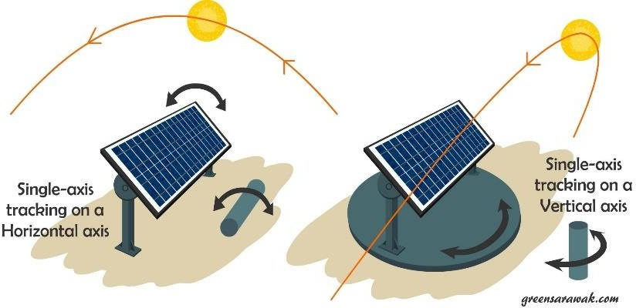

**Figure 2.1: Single axis solar tracker.**

**Dual axis tracking:**

This system has two degrees of freedom that are perpendicular to one another. These tracking devices are divided into two types: tip-tilt trackers and azimuthal-altitude trackers. Dual axis tracking systems can be used for both passive and active tracking strategies.

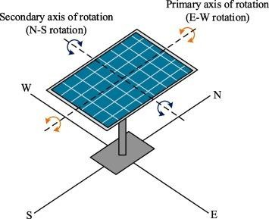

**Figure 2.2: Dual axis solar tracker**

# CHAPTER 3

## HARDWARE COMPONENTS

### HARDWARE COMPOINENTS

In our project “DUAL AXIS SOLAR TRACKER” we use only Hardware components instead of any Software components. The following components are used in making of our project;

### List of the components

* + 1. VPC cardboard.
    2. Solderless breadboard.
    3. LM 358 IC.
    4. 555 Timer IC.
    5. LDR sensor.
    6. L293D motor driver IC.
    7. Resistors (1k, 10k).
    8. Capacitors (103pf, 104pf).
    9. Variable resistors (10K, 100K).
    10. 4148 Diode.
    11. MG996R Servo motor.
    12. LED.
    13. DC fan.
    14. Solar panel.
    15. DC to DC boost convertor LM2587.
    16. LiPo Battery charger module mini TP4056 IC.
    17. ON/OFF Switch.
    18. 18650 Battery holder.
    19. 18650 Battery cell.

### About components

### Basic components

1. **Cardboard:**

We used a VPC carboard as a stand and base for our project. A motor is attached to one carboard to rotate in x-axis and another is attached to another piece of carboard to rotate in y-axis.



**Figure 3.1: Carboard**

1. **Breadboard:**

Solderless breadboards are used to prototype circuits without the requirement of generating a Printed Circuit Board [PCB]. Breadboards may be used to test and evaluate new circuit designs in development or prototype changes in a existing designs. Unlike a perf - board or stripboard, breadboards do not require soldering or destruction of tracks and are hence reusable. For this reason, breadboards are also popular with students and in technological education.

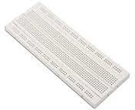

**Figure 3.2: Solderless breadboard**

1. **Resistors:**

A resistor is a passive two-terminal electrical component that implements electrical resistance as a circuit element. In electronic circuits, resistors are used to reduce current flow, adjust signal levels, to divide voltages, bias active elements, and terminate transmission lines, among other uses. High-power resistors that can dissipate many watts of electrical power as heat may be used as part of motor controls, in power distribution systems, or as test loads for generators.

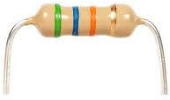

**Figure 3.3: Resistor**

1. **Capacitor:**

A capacitor is a device that stores electrical energy in an electric field by virtue of accumulating electric charges on two close surfaces insulated from each other. It is a passive electronic component with two terminals. The effect of a capacitor is known as capacitance. While some capacitance exists between any two electrical conductors in proximity in a circuit, a capacitor is a component designed to add capacitance to a circuit. The capacitor was originally known as a condenser, a term still encountered in a few compound names, such as the condenser microphone.

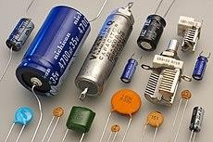

**Figure 3.4: Capacitor**

1. **Variable resistor:**

A variable resistor is a resistor of which the electric resistance value can be adjusted. A variable resistor is in essence an electro-mechanical transducer and normally works by sliding a contact (wiper) over a resistive element. When a variable resistor is used as a potential divider by using 3 terminals it is called a potentiometer. When only two terminals are used, it functions as a variable resistance and is called a rheostat. Electronically controlled variable resistors exist, which can be controlled electronically instead of by mechanical action. These resistors are called digital potentiometers.

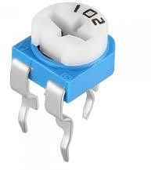

**Figure 3.5: Variable resistor**

1. **LED:**

A light-emitting diode (LED) is a semiconductor device that emits light when current flows through it. Electrons in the semiconductor recombine with electron holes, releasing energy in the form of photons. The colour of the light (corresponding to the energy of the photons) is determined by the energy required for electrons to cross the band gap of the semiconductor. White light is obtained by using multiple semiconductors or a layer of light-emitting phosphor on the semiconductor device.

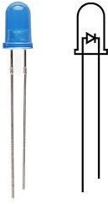

**Figure 3.6: Light Emitting Diode**

1. **DC Fan:**

DC fans are widely regarded as the most efficient type of fans. They consume significantly less power than AC fans. In fact, DC fans consume up to 70 percent less energy to produce the same output as traditional AC fan types.

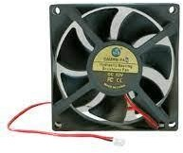

**Figure 3.7: DC fan**

1. **Switch:**

The function of switch in an electric circuit is to either make or break the electric circuit. A switch is used to turn current to an electrical appliance either on or off.

(or)

In electrical engineering, a switch is an electrical component that can disconnect or connect the conducting path in an electrical circuit, interrupting the electric current or diverting it from one conductor to another.

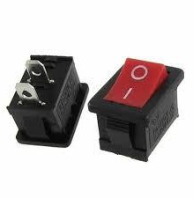

**Figure 3.8: Switch**

1. **18650 Battery holder:**

The primary function of a battery holder is to keep cells fixed in place safely and securely while conveying power from the batteries to the device in question. External connections on battery holders are most often made by contacts either with pins, surface mount feet, soldered lugs or via a set of wire leads.

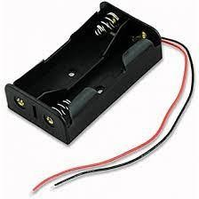

**Figure 3.9: Battery holder**

### Main components

1. **555 Timer IC:**

The 555 timer IC is an integrated circuit (chip) used in a variety of timer, delay, pulse generation, and oscillator applications. Derivatives provide two (556) or four (558) timing circuits in one package. The design was first marketed in 1972 by Signetics. Since then, numerous companies have made the original bipolar timers, as well as similar low- power CMOS timers. In 2017, it was said that over a billion 555 timers are produced annually by some estimates, and that the design was "probably the most popular integrated circuit ever made”.

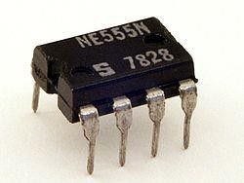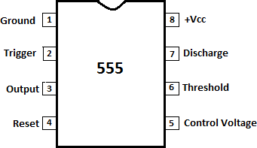

**Figure 3.10: 555 Timer IC with pin configuration**

Bistable mode, the 555 timer acts as an SR flip-flop. The trigger and reset inputs are held high via pull-up resistors while the threshold input is grounded. Thus configured, pulling the trigger momentarily to ground acts as a "set" and transitions the output pin to VCC (high state). Pulling the reset input to ground acts as a "reset" and transitions the output pin to ground (low state). No timing capacitors are required in a bistable configuration. The discharge pin is left unconnected or may be used as an open-collector output.

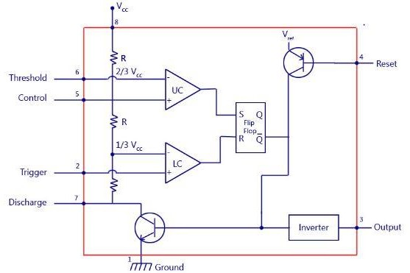

**Figure 3.11: Internal block diagram of 555 Timer IC**

**Voltage divider**- Between the positive supply voltage VCC and the ground GND is a voltage divider consisting of three identical resistors (5 kΩ for bipolar timers, 100 kΩ or higher for CMOS) to create reference voltages for the comparators. CONTROL is connected between the upper two resistors, allowing an external voltage to control the reference voltages.

**Threshold comparator** - The comparator's negative input is connected to voltage divider's upper reference voltage, and the comparator's positive input is connected to THRESHOLD.

**Trigger comparator** - The comparator's positive input is connected to voltage divider's lower reference, and the comparator's negative input is connected to TRIGGER.

**Flip-flop** - An SR flip-flop stores the state of the timer and is controlled by the two comparators. RESET overrides the other two inputs, thus the flip-flop (and therefore the entire timer) can be reset at any time.

**Output** - The output of the flip-flop is followed by an output stage with push–pull (P.P.) output drivers that can supply up to 200 mA for bipolar timers, lower for CMOS timers.

**Discharge** - Also, the output of the flip-flop turns on a transistor that connects DISCHARGE to the ground

1. **LM358 IC:**

LM358 IC is a dual operational amplifier integrated circuit with two Op-Amp powered by a common power supply. It consists of two independent compensated operational amplifiers with low power and high gain frequency. LM358 is specially designed to operate from a single supply over a wide range of voltage.

It is more flexible for low voltage AC and moderate voltage DC applications. LM358 is available in a cheap-sized package so it is widely used in real-life applications including transducer amplifier, DC gain block, active filter, and conventional op-amp circuit design. LM358 IC can handle 3V- 32V DC supply and source up to 20 mA per channel.

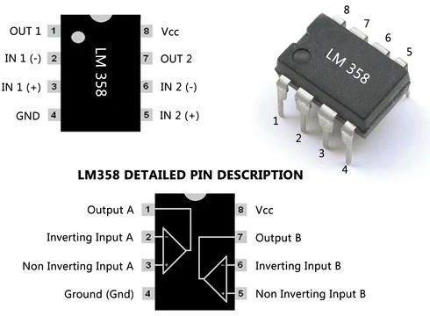

.

**Figure 3.12: LM358 IC Pinout**

Some important features and specifications of LM358 IC are as follows:

* + Integrated with two operational amplifiers in a single package
  + Wider range of power Supply.
  + The large voltage gain is around 100 Db.
  + Wider bandwidth in 1 MHZ.
  + The output voltage swing is high.

1. **L293D IC:**

The Device is a monolithic integrated high volt-age, high current four channel driver designed to accept standard DTL or TTL logic levels and drive inductive loads (such as relays solenoids. DC and stepping motors) and switching power transistors. To simplify use as two bridges each pair of channels is equipped with an enable input. A separate supply input is provided for the logic, allowing operation at a lower voltage and internal clamp di-odes are included. This device is suitable for use in switching applications at frequencies up to 5 kHz. The L293D is assembled in a 16-lead plastic package which has 4 centre pins connected to-gather and used for heatsinking. The L293DD is assembled in a 20-lead surface mount which has 8 centre pins connected together and used for heatsinking.

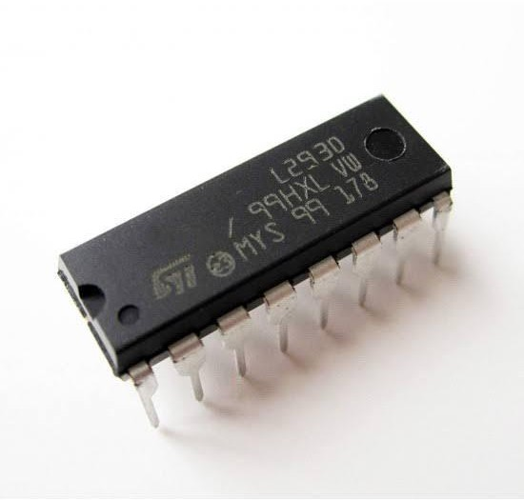

**Figure 3.13: L293D IC**

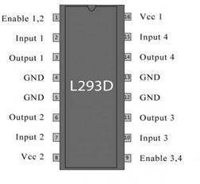

**Figure 3.14: L293D Pin configuration**

1. **4148 Diode:**

1N4148 diode is mainly used for quick switching purposes, so these are known as switching diodes. The main functionality of these diodes is the same as a normal switch. These diodes have high resistance under a fixed voltage whereas they have low resistance above the fixed voltage. This kind of diode is easily available in a tiny size with less cost. So, the selection of this diode can be done based on its highest reverse recovery time as well as its power dissipation that ranges from 80milli Watts to 1kilo Watts.

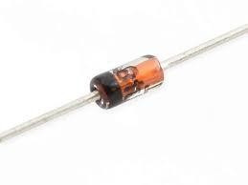

**Figure 3.15: 1N4148 Diode**

1. **MG996R Servo motor:**

The MG996R is a metal gear servo motor with a maximum stall torque of 11 kg/cm. Like other RC servos the motor rotates from 0 to 180 degree based on the duty cycle of the PWM wave supplied to its signal pin.

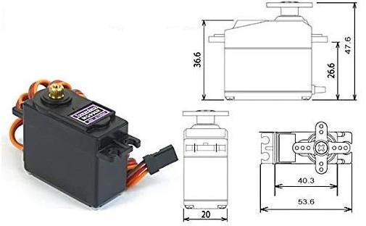

**Figure 3.16: MG996R servo motor with dimensions**

1. **LDR Sensor:**

An LDR is a component that has a (variable) resistance that changes with the light intensity that falls upon it. This allows them to be used in light sensing circuits. The most common type of LDR has a resistance that falls with an increase in the light intensity falling upon the device (as shown in the image above). The resistance of an LDR may typically have the following resistances:

Daylight = 5000Ω. Dark = 20000000Ω.

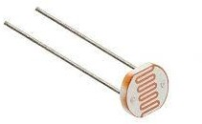

**Figure 3.17: LDR Sensor**

**Working Principle of Light Dependent Resistor:**

The working principle of an LDR is photoconductivity, which is nothing but an optical phenomenon. When the light is absorbed by the material then the conductivity of the material enhances. When the light falls on the LDR, then the electrons in the valence band of the material are eager to the conduction band. But, the photons in the incident light must have energy superior to the bandgap of the material to make the electrons jump from one band to another band (valance to conduction). Hence, when light having ample energy, more electrons are excited to the conduction band which grades in a large number of charge carriers. When the effect of this process and the flow of the current starts flowing more, the resistance of the device decreases.

1. **DC to DC boost convertor:**

The LM2587 3A 30V DC-DC Boost is a fantastic tool for any Electronics toolbox or workbench, and is capable of converting input voltages of between 3.5V and 30V, up to an output voltage of between 4V and 30V. It operates at a maximum efficiency of 92%, and can provide up to 20W maximum power output.

LM2587 boost convertor specifications:

* + Output Voltage: – 4V - 30V
  + Max Output Power: – 20W
  + Module Type: – Non-Isolated Boost
  + Output Current: – 3A (Max)

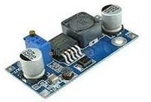

**Figure 3.18: LM2587 boost convertor**

1. **18650 Battery cell:**

An 18650 battery is a rechargeable lithium-ion battery. They tend to have a nominal voltage of 3.6V and range in capacity from 1800mAh to 3600mAh. In all honesty, the name of the 18650 isn't particularly inventive. The 18 is for the 18mm width of the battery and the 65mm is for the length.

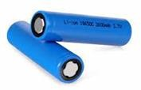

**Figure 3.19: Battery cells**

1. **LIPO mini battery charging module**:

TP4056 Micro USB 5V 1A Lithium Battery Charger Board Protection Module is a complete constant-current / constant voltage linear charger for single cell lithium-ion batteries. It's SOP package and low external component count make the TP4056 ideally suitable for portable applications. TP4056 module features a widely available micro-USB connector and with a led indicator for state detection.

TP4056 Module Specifications:

* + Input voltage: 4.5V ~ 5.5V
  + A full charge voltage: 4.2V
  + Power: 4.2 w
  + Charging accuracy: 1.5%
  + Charging indicator: micro-LED
  + Input Interface: Micro USB port
  + Charging method: linear charge
  + Operating Temperature: -10 to +85ºC

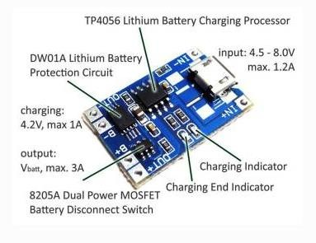

**Figure 3.20: TP4056 Mini battery charging module**

1. **Solar panel:**

Solar panels (also known as "PV panels") are used to convert light from the sun, which is composed of particles of energy called "photons", into electricity that can be used to power electrical loads.

Solar panels can be used for a wide variety of applications including remote power systems for cabins, telecommunications equipment, remote sensing, and of course for the production of electricity by residential and commercial solar electric systems.

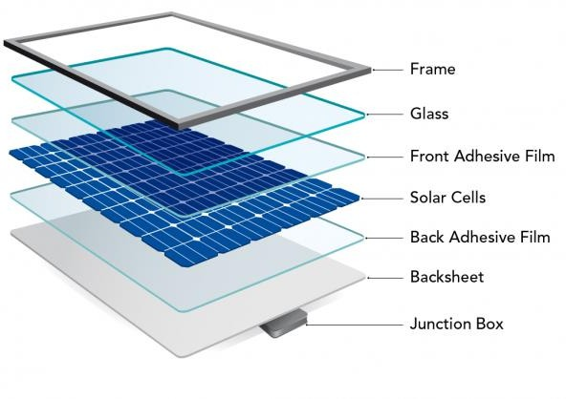

**Figure 3.21: Layers of a solar panel**

**Working of solar panels:**

Solar panels collect clean renewable energy in the form of sunlight and convert that light into electricity which can then be used to provide power for electrical loads. Solar panels are comprised of several individual solar cells which are themselves composed of layers of silicon, phosphorous (which provides the negative charge), and boron (which provides the positive charge). Solar panels absorb the photons and in doing so initiate an electric current. The resulting energy generated from photons striking the surface of the solar panel allows electrons to be knocked out of their atomic orbits and released into the electric field generated by the solar cells which then pull these free electrons into a directional current. This entire process is known as the Photovoltaic Effect.

# CHAPTER 4

## DUAL AXIS SOLAR TRACKING SYSTEM

### Block diagram

**Brief explanation:**

The complete operation of the dual axis tracking system wholly depends on the light dependent resistor (L.D.R) which is used as a sensor whose resistance decreases with increasing light intensity. The fully geared stepper motors are implemented for the rotation of the solar panel in two different axes. This dual axis design consists of four LDRs which are placed on the solar panel for detecting the light intensity. The main objective of this system is to make the panel always face the sun in order to maximize the energy absorbed thus giving greater efficiency to drive loads that require more power.

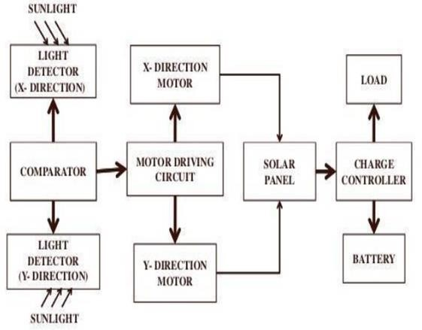

**Figure 4.1: Functional block diagram**

**Block explanation:**

The panel consists of two pairs of LDR’s (Light Dependent Resistors) which are used to track the sun’s exact position is along the inclined axis and along the azimuth axis. (LDR is a resistor whose resistance decreases with increasing incident light). When any of the LDR receives maximum intensity radiation its resistance decreases. This information is sent to the light comparison unit which further transfers this information to the microcontroller.

The microcontroller is the main control unit of the whole system, which determines the direction of movement of the motors in both azimuth and vertical axis. The implementation of the LDR is based on shadow effect. If the solar panel is not perpendicular to the sun’s rays the shadow will cover only one or two LDRs, this causes different light intensity to be received by the sensing device. The output signal from the microcontroller is supplied to the DC motor which gives step motion to the panel accordingly to the incident radiation.

The solar panel will accordingly start’s tracking the sun’s position and capture the solar power. This is given to a charge controller used to control the solar power at the output. The solar power can be stored in various types of batteries such as lead-acid batteries, lithium-ion batteries, nickel-cadmium batteries, lithium-ion batteries and flow batteries. (Here, we are using lithium-ion batteries for storing the solar power). This solar power is used to drive the load that are connected at the output. The load can be LED’s, DC fans, etc.,

### Flow chart

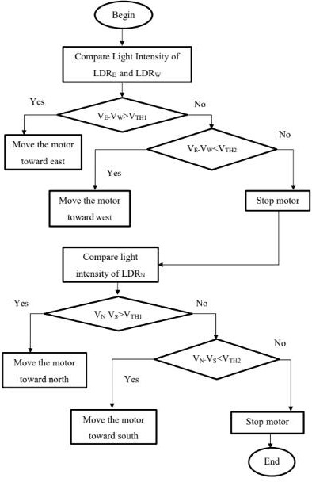

**Figure 4.2: Algorithm for tracking**

### Circuit diagram

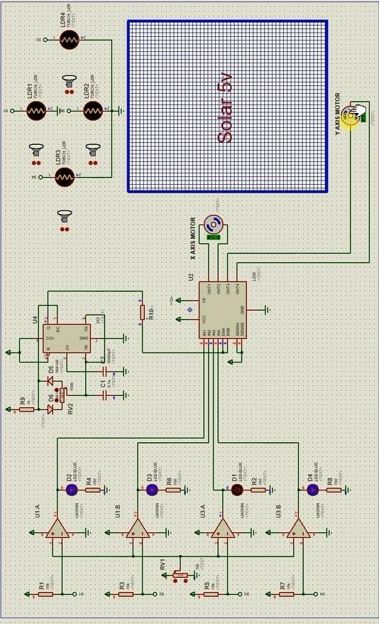

**Figure 4.3: Circuit diagram of dual axis solar tracking**

### Working of the circuit:

By using 4 LDR’s (Light Dependent Resistors), which are placed on the top of the panel we are able to moves the solar panels according to the sun’s position. Also, we have used low pass filter and this filter is a LM358 IC low pass filter, where two filters are connected across x-axis and another two are connected across y-axis. Here a 555 IC is used to generate required PWM pulses for L293D Motor driver IC, hence L293D works as output driver. This L293D is a 16-pin Motor Driver IC which can control a set of two DC motors simultaneously in any direction (x and y directions) and it can also control the speed of those motors. This 555IC is connected to the L293D IC which is connected at the enable pins A and B to control the speed of the MG996R Servo motor.

When light is incident on 4 LDR’s at a time then the position of the solar panel is stationary. But when light is incident on either 1 and 2 LDR’s or 3 and 4 LDR’s the panel starts moving at a side where the intensity of the light is maximum. In our project, the panel can move in dual axis i.e., it can move side-to-side or top-to-bottom. When intensity of the light is more at 1st LDR which is placed at top, the panel moves in upward direction. When intensity of the light is more at 2nd LDR which is placed below the 1st LDR, the panel moves in downward direction. Similarly, when the intensity of light is more at 3rd LDR it moves in left hand side and the intensity of light is more at 4th LDR, the panel moves in right hand side.

When the solar panel is exposed to sun light, it captures solar energy. Here 18650 rechargeable batteries are used to store this solar energy by using a LIPO mini charging module. This energy is taken as output and pass it through a DC-to-DC boost convertor which helps to drive the load connected across it.

# CHAPTER 5

## PERFORMANCE ANALYSIS & RESULTS

Figure 5.1 depicts the current and voltage values received from both the static and tracking panels at various times of the day. The table shows that at 8:00 a.m., the tracking panel significantly outperforms the static panel in terms of current. However, as time passes, the current difference between these two technologies narrows to around 1:00 pm. This difference then increases as the sun rotates more towards the west. At 12:00 p.m., the static panel and tracking panel have the highest currents of 0.31 amp and 0.34 amp, respectively. However, the variation in voltage is less than that in current because voltage has no direct relationship with the intensity of the sun's light.

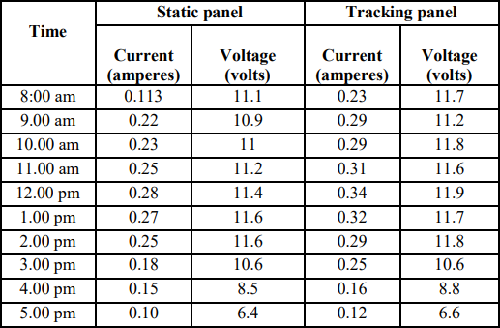

**Fig 5.1: Current and voltage values of static and tracking panel at different times in day**

The output performance compared to the static panel and single axis solar panel on our working model performed better. The values of the output obtained using our model are displayed in the two graphs below. Performance is depicted throughout the day in the first graph (Fig. 5.2), and output between the various tracking systems is compared in the second graph (Fig. 5.3).

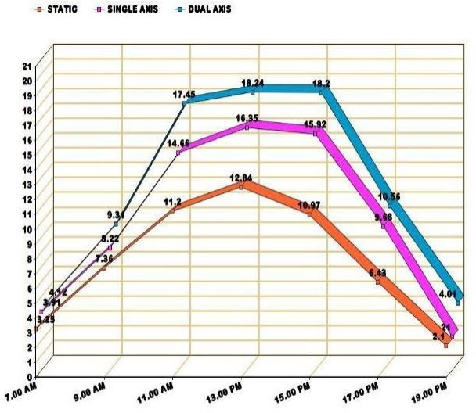

**Figure 5.2: Day based obtained output**

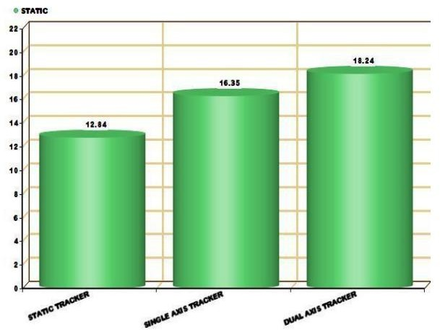

**Figure 5.3: Comparison with static and single axis**

# CHAPTER 6

## RESULT

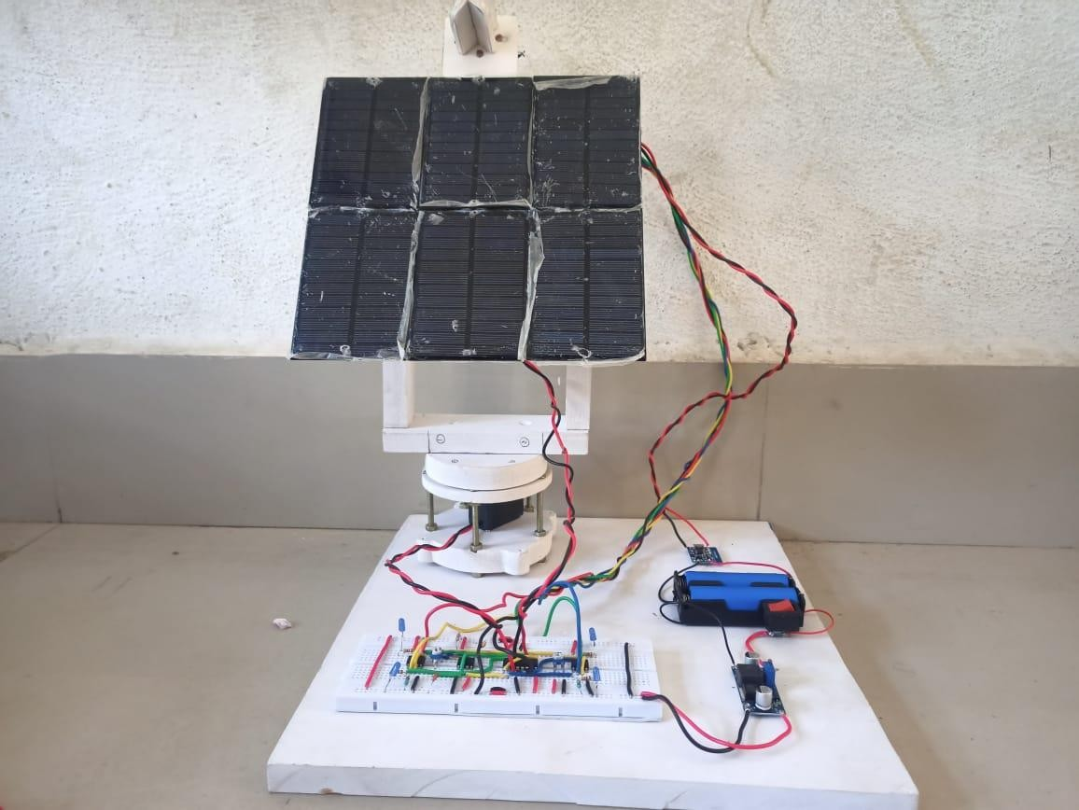

**Figure 6.1: Model of Dual axis solar tracking system**

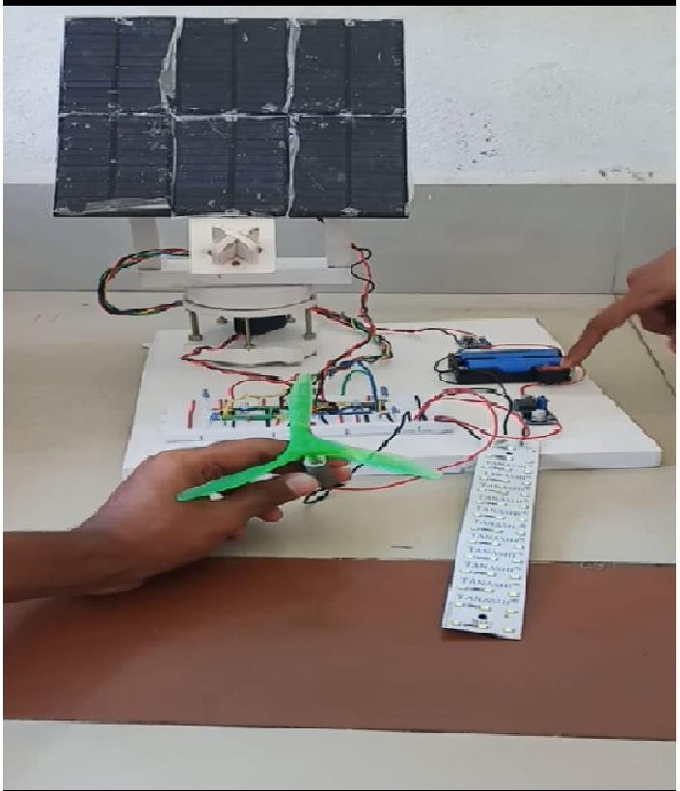

**Figure 6.2: Dual axis solar tracker with DC fan and LED as output**

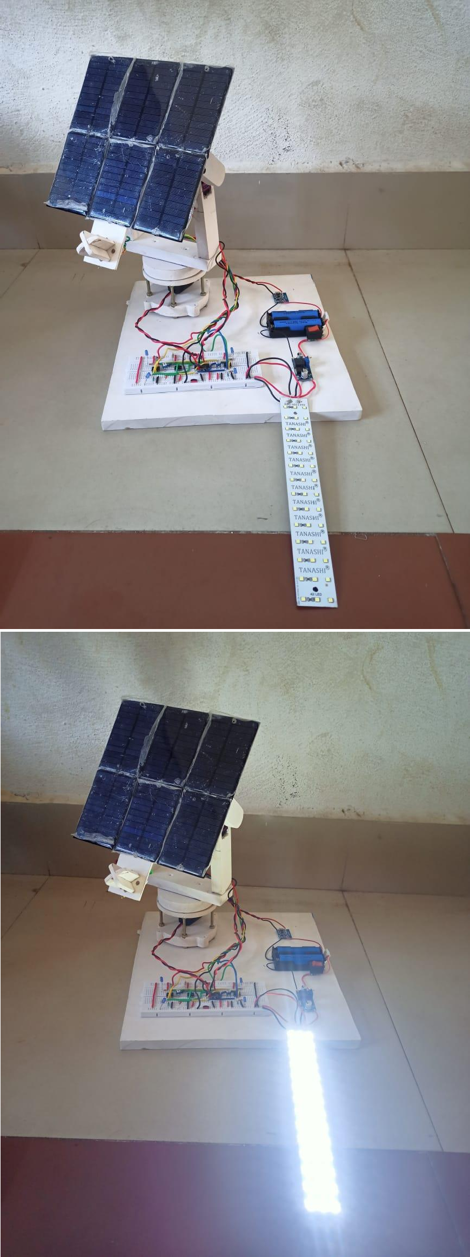

**Figure 6.3: Dual axis solar tracker with LED ON & OFF**

# CHAPTER 7

## CONCLUSION

The empirical findings lead us to believe that the research work may provide some contributions to the development of solar energy applications like;

* A simple and cost-effective control implementation.
* A stand-alone PV inverter to power the entire system.
* Ability to move the two axes simultaneously within their respective ranges.
* Ability to adjust the tracking accuracy.
* Applicable to moving platforms with the Sun tracker.

A dual axis solar tracking system was successfully designed, built, and tested in our project. It allows the sun's path from morning to evening before returning to its original position facing east. As a result, the system saves a lot of energy by turning off the motors at night. This tracking technology is designed to be simple, low-cost, and accurate. There are several solar technologies on the market. However, when compared to both fixed solar panel and single axis solar tracking technologies, this dual axis tracking technology has a higher energy gain.

# CHAPTER 8

## FUTURE SCOPE

Various changes can be made to this model and implemented as a secondary source of energy in schools, offices, and so on. This tracking system, which stores enough energy throughout the day to be used at night, can also replace the street lighting system. Efforts should be made to implement this on a large scale in the future to meet rising energy demands.

This project completely redesigns and expands the sun tracking system. It outperforms the stationary solar panel and single axis solar tracker in terms of performance and efficiency. This project can be improved further to track the sun's position not only in the x and y axes, but also in the Z-axis (depth), A-axis (rotation around the X axis), and B axis (rotation around the Y axis).

* Floating solar farms (floatovoltaics) are cheaper to install and can produce more power than land-based solar panels due to the cooling effect of water.
* Building-integrated solar tech allows you to incorporate solar panel production into the architecture of a building.
* The development of solar fabrics would allow for clothing that can generate solar power while you’re on the move.
* Solar noise barriers can be used on roads and highways to generate solar power while reducing noise pollution.

# CHAPTER 9

## REFERENCES

1. Mousazadeh, Hossein, et al. A review of principle and sun-tracking methods for maximizing solar systems output. Renewable and Sustainable Energy Reviews. 2009. 10.1016/j.rser.2009.01.022.
2. Poulek V. Rapid Publication New low-cost solar tracker. 1994. pp. 287-291.
3. Tracking Of Solar Panel by Hydraulic System. K, Kusekar S, et al. 28, 2015, International Journal of Informative & Futuristic Research ISSN (Online International Journal of Informative & Futuristic Research, pp. 2347-1697.
4. Dual Axis Solar Tracking System for Solar Panel. Singh, Purnima, et al. 4, 2016, Bulletin of Electrical Engineering and Informatics, Vol. 5, pp. 2302-9285. 10.11591/ eei.v5i4.565.
5. Hafez, A. Z., Yousef, A. M. and Harag, N. M. Solar tracking systems: Technologies and trackers drive types – A review. Renewable and Sustainable Energy Reviews. 2018. 10.1016/j.rser.2018.03.094.
6. Sumathi, Vijayan, et al. Solar tracking methods to maximize PV system output – A review of the methods adopted in recent decade. Renewable and Sustainable Energy Reviews. 2017. 10.1016/j.rser.2017.02.013.
7. New solar tracker. Poulek, V. and Libra, M. 1998, Solar Energy Materials and Solar Cells. 10.1016/S0927-0248(97)00276-6.
8. High concentration low wattage solar arrays and their applications. Hoffmann, Robert, et al. 1997, Vol. 394, p. 739. 10.1063/1.52874.
9. Chiang, Luciano E and Jacob, Jorge E. Low-cost sun-tracking photovoltaic panel. 1998.
10. Study on Automatic Sun-Tracking Technology in PV Generation. Chun-Sheng, Wu, et al. 2008.